INTRODUCTION
The Literature Translation Institute Korea (KLTI) had led the effort to translate and internationalize Korean literature. This effort has been marked with increasing success within the last few years. Korean modern literature has flowered on the international scene, with many of the successful international works either directly translated or funded by KLTI, or written by authors who were originally translated and funded by KLTI. Particularly, with the recent success of Kim Young-ha and Shin Kyung-sook, it becomes increasingly apparent that a kind of international threshold has been reached by Korean translated literature. Given this achievement, what can the KLTI do to build on and increase the achievement and impact of translated Korean literature?
Three recommendations come to mind. First, explicitly survey and analyze the audience that might read Korean translated fiction. Second, consider how this audience can best be reached and consider non-traditional approaches to them. Third, assess translation goals against results in order to fine-tune the translation process from its beginning (even to the point of text choice) to its end (including such traditionally “non-translation” issues as who publishes works, and even details such as cover design).
As the second of these points is most important to my mind, I must recognize that the marketing focus of these recommendations might unsettle some, particularly those who, correctly, focus on the importance of communicating essentially Korean culture through translation. However this paper will argue that marketing-based translation is the one of the most effective techniques for fostering success of even broader, culture-based, translations.
Reading through all the papers for this conference I came upon this quote from Suh Seong-chul (Pusan University of Foreign Studies) and despaired that I would have nothing to add. Suh summarized:

There are many recurring issues in the discussion of internationalization of Korean literature: availability of good translators; how to select what to translate – novel vs. poetry, classic vs. contemporary work; quality and quantity of translations; which foreign publisher to contact for distribution; and, finally, how to promote translated works.
And worse, Professor Suh goes on to steal all my thunder with:
If the purpose of our work is to introduce our culture through Korean literature, selecting classical works should be preferred. On the other hand, in terms of attracting foreign readers, selecting more contemporary works would be a good idea.
I sense a marketing director in training!
Also, I was particularly impressed by Lee, Ho-chul’s recognition that Korea’s current overseas cultural triumphs could not come, “without solid foundation of “literature” that supports such cultural success.”
And that is why I am here, and you are here. Because without the support of literature it is extremely difficult to have a culture, or at any rate a culture worth noting.

I: IDENTIFY AUDIENCE(S)
Surveying the last40 years of translation, it is clear that much translation was undertaken without analysis of its intended audience. This first reveals itself in the topics chosen for translation – topics of extreme importance to Koreans, but topics with no points of access for readers in other languages. Such a survey also reveals the perhaps less obvious but even more telling point; where the books were published and where the books were sold.
Many translated works centered on colonialism, were pundan munhak, or strongly related to deep Korean culture, but contained little content that would be apprehensible to overseas readers who have little knowledge of Korean history. Research reveals that the bulk of the books that have been translated are not being read by English-language readers. As PLKF figures demonstrate, at least with the most commercially successful books, works that contain comprehensible content simply sell better. A comparison with cuisine might sum this up – if a Korean restaurant were to sell 홍어 and 불구기 in New York, the relatively familiar food would certainly sell better. If you begin by selling 홍어 very few foreign diners would follow Korean food to 불구기 , while if you do it the other way around you will have hordes of pleased eaters, some of whom might go on to enjoy 홍어.
The second point speaks to improvements that can be made after the translation process. We will shortly take a look at the Portable Library of Korean Fiction (PLKF) books as well as other major translations of the last few years and discover that not only are they only sporadically published outside Korea, but in fact many are unknown and never sold outside Korea. In this case, translation organizations overlooked the most salient point about English language readers – Overseas readers lived overseas! Additionally, statistical studies demonstrate (Montgomery, Genre and Translation, p. 5) that works published overseas are far more successful than those published in Korea.
II: SERVE AUDIENCES
Once the interests of the audience have been properly identified, what should be done?
Bluntly, cater to them.
And cater to the greatest audience you can hit. In her excellent explanation of what Columbia Publishing does, Jennifer Crewe said:
I am looking for fiction whose author is highly respected both in Korea and by scholars who teach Korean literature in the United States, and for work that will appeal to college students, and that could be assigned in Korean literature or history courses in the US. For example, work that depicts life during a particular time in Korean history--the colonial period, for example (Yi T'aejun's Eastern Sentiments is one example from our list), or whose characters are dealing with a traumatic event in Korean history (for example Park Wan-shu's Who Ate Up All the Shinga?, or a novel by Sok-pom Kim, written in Japanese by an author of Korean descent, called The Curious Tale of Mandogi's Ghost, about the Four-Three Incident of 1948). These books are often used to help teach history.
This is not what I, as an ex marketing director, am looking for. This is a proper strategy within the academic world, and a strategy that should be followed there. But it is the kiss of death outside of academia. Outside of academia most successful literature is not “highly respected” in the sense that Crewe searches for.
Both of the most successful translations in recent history, Your Republic is Calling You and Please Look After Mom, were translated by Chi-young Kim, who KTLIT had the opportunity to interview (KTLIT). Kim was quite clear of three things: First, literal translation was often a quick path to failure; Second, authors Kim and Shin were willing to re-write their work to facilitate understanding in English, third; multiple editors were necessary to achieve versimilitude in English. You must give potential readers points of access to fiction unless you want your translations to gather dust in academic libraries. When Kim translates, she concentrates on making her work comprehensible to the reader, a concentration that has not always been present in translation of Korean literature.
Genre is also important. Potential readers need points of access to new fiction. Your Republic is Calling You and Please Look After Mom are both immediately categorizable to English-speaking readers. Kim Young-ha’s book is a mystery/thriller, and Shin Kyung-sook’s is an Oprah-type tearjerker. In the interests of accessibility to western audiences, even the titles were changed, and not only from their literal meanings in Korean: In the case of Shin Kyung- sook’s Please Look After Mom, there were two different titles in English (to accommodate US/UK differences in idiom).
Looking one step closer, we can see that even the covers were designed to emphasize the genred nature of the books, and this certainly helped potential readers decide to choose them. The success of these two books should not come as a surprise. Compare these covers to the book covers of the otherwise excellent PLKF publications. These covers feature dull monotones and reversed-hangul designs that are difficult to decipher even if one reads Korean, much less if one is an English-language reader.
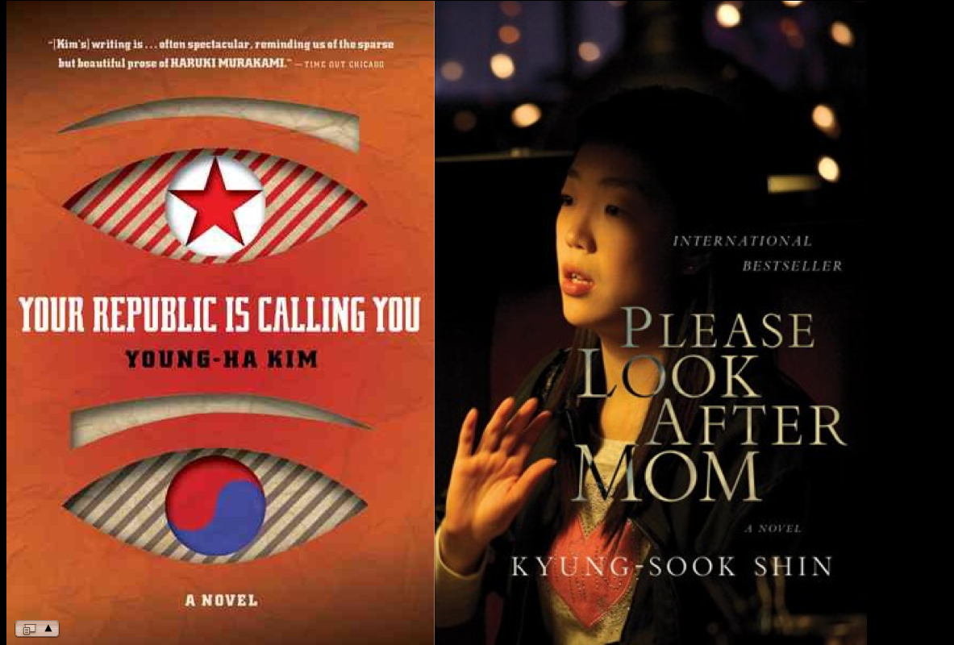

Do not think, however, that this kind of focus betrays other more traditional goals of translation; that is, to explain and promulgate Korean culture overseas. There is an old U.S. economic saying that, “a rising tide floats all boats.” And this seems to be true with genred success in Korean translation. When Park Wan-so’s Who Ate Up All The Shinga became a minor success in English, it buoyed up her other translated works (again, as measured on Amazon ratings). When Kim Young-ha’s Your Republic is Calling You became a larger hit, it buoyed up his other translated works.
But the effect is far more wide-reaching than the success of specific authors suggests. In fact, studies of the Amazon rankings of the PLKF indicate that the success of genred fiction creates a parallel success in more traditional translated fiction across the board. As the success of Kim Young-ha’s “Your Republic is Calling You” waned, so did the average ranking of PLKF books, falling over 12%. On the other side of the coin, the massive publication success of Shin Kyung-sook’s book provided the PLKF books with an aggregate ‘bounce’ of over 20%. The evidence seems to suggest that the success of international bestsellers actually drives the success of the larger body of Korean modern fiction.
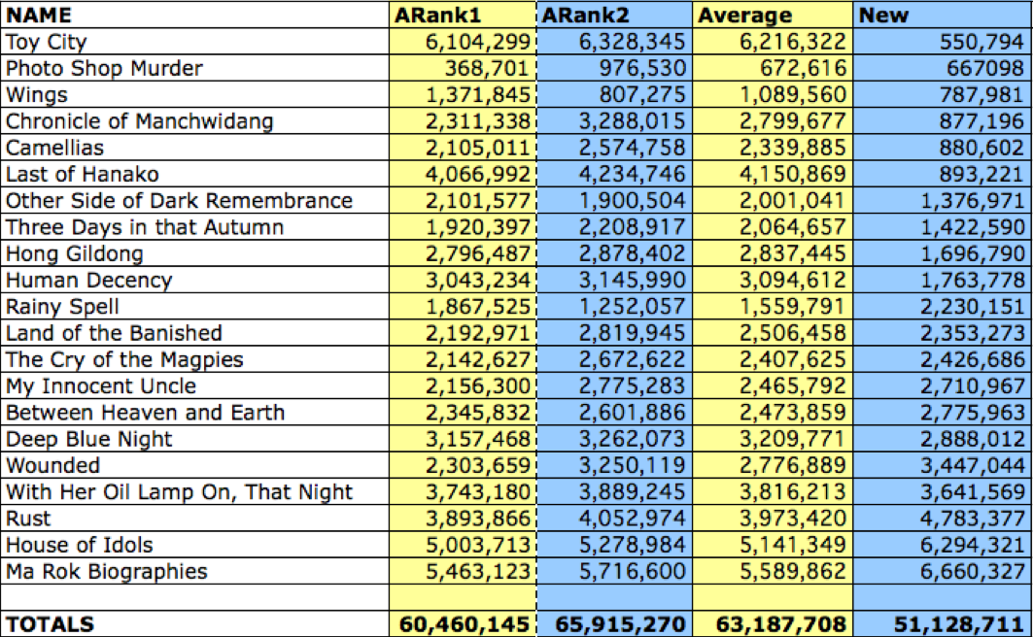

Basically, this shows that as the popularity of Your Republic is Calling You waned, so did the overall success of the LTI Korea/Jimoondang books. But when Please Look After Mom took off, the LTI Korea/Jimoondang books shot up between 15% and 22.5% depending on how you defined the baseline.
This is at least partly due to the ‘suggestive’ nature of the internet, as Amazon and Barnes and Noble have a recommendation feature that suggests related literature to browsers who are interested in Korean literature bestsellers. Any potential reader searching for Please Take Care of Mother will also at least lay their eyes on three other works of Korean fiction on these pages, and this is a powerful branching tool.
I will return to the internet shortly.
Focus on women! In her excellent presentation here today Katharina Borchardt noted that, “one must not forget that most readers are women. Women spend much more money on books than men. One should not neglect them as readers, as Korean translations have done for a long time.”
Also, consider aiming for literary awards that fall short of the Nobel Prize for Literature. Just last month KTLIT was approached, at the absolute last minute, by the Man Asia Literary Prize, which, for the second year running, was to feature no Korean entrants, even on its long list. In twenty-one years (TWENTY-ONE) there had been no Korean entrants in the long list for the “Independent Foreign Fiction Prize,” a prize originally given by the British Newspaper The Independent and now administered by Arts Council England. This is astounding.
Collections of short stories are famously difficult to sell, but this does not mean that short stories should be ignored. But rather than collect them, place them in magazines. Take advantage of interest in such writers as Kim Young-ha (Atlantic Magazine) and Yi Mun-yol (The New Yorker).
One last suggestion, with respect to reaching potential readers; utilize social media, and define social media as widely as possible. The Internet is now the primary way that most people in the English-speaking world do their research and the lack of information available online (either on Google or the Wikipedia, the primary sources of search, and even on Amazon) about Korean fiction is shockingly sparse.
At the same time, the role of the book is changing rapidly. No one can say exactly where this will lead authors, the publishing industry, or even literature, but it is a sea-change. Recently, the Ewan Morrison noted in the Guardian:
Barnes and Noble claims it now sells three times as many digital books as all formats of physical books combined. Amazon claims it has crossed the tipping point and sells 242 ebooks for every 100 hardbacks, while Richard Sarnoff, CEO of Bertelsmann, admits that the future of the paper book is tied to the consumption habits of a generation: the baby boomers. Generation Y-ers (the children of the boomers) already consume 78% of their news digitally, for free, and books will follow suit. Interpreting Sarnoff's calculations, the paper book has a generation left.
One of the historical problems with the success of translated Korean Literature has been its inability to get published overseas, but the Internet can at least partially eliminate that barrier. In the past, publication itself was often the barrier that stopped translations. E-publication and the Internet make this publication possible at the click of a mouse.

About the “book” (whatever that might have been in terms of Platonic concept) we will shortly be crying, “The book is dead. Long live the book!” And the new book will continue, just as lines of regents did.

What we will see is an erosion of the position of books that have previously achieved “so-so” status, and the general elision of the role of the author. David Wills’ point that “Over the past 100-odd years it seems everyone has tried their hand at writing, and inevitably it’s become unsustainable,” is what is likely to continue. What we are going to see is the literary semi-equivalent of Gresham’s law, as bad writing (to some extent) drives out good writing, or merely drowns it in fecundity. Good writing may become more difficult to find as the gate-keepers of the publication threshold lose their power.

Of course there will also be some ‘positive’ results as groups that previously could not surpass the threshold – furries, cultists, emo kids, etc. – will now be able to publish and read exactly what they want to. Back when it was more difficult to publish, the barrier to publication meant that a smaller number of works were published. This increased the chance that any one work might be successful, because it had, 1) fewer competitors to overcome, 2) Some imprimatur merely by nature of having achieved publication, and 3) Less noise (this is related to point #1). Consequently, authors that did come into the public eye were esteemed, if only by virtue of their relative scarcity.
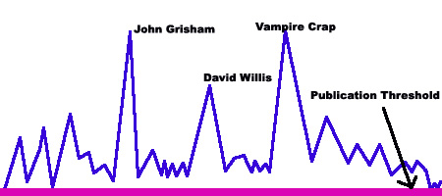

As, however, the publication threshold has loosened, more and more works are published in the space at the bottom of the book food chain. At the lower levels, this reduces the cachet of the author (which was based, really, on the cachet of publication).
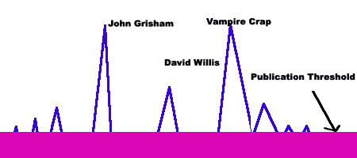

And here I would like to point out something quite wonderful, but as yet not well known, that LTI Korea has done along these lines – something that gives me confidence that they are on the right track. LTI Korea has created a podcast channel in iTunes that features some 67 video podcasts on modern Korean literature. The videos are produced by Arirang and feature high production quality and generally interesting topics, although they come with some of the predictable issues that can come along with Arirang production. In any case, part of the future lies along these lines and it is important to get out ahead of these trends. An article in the New Yorker about hacking and social media, points out that in this new and quickly changing environment, savvy producers must not fear failure, must get product out quickly rather than entirely completely, and then iterate, iterate, iterate.
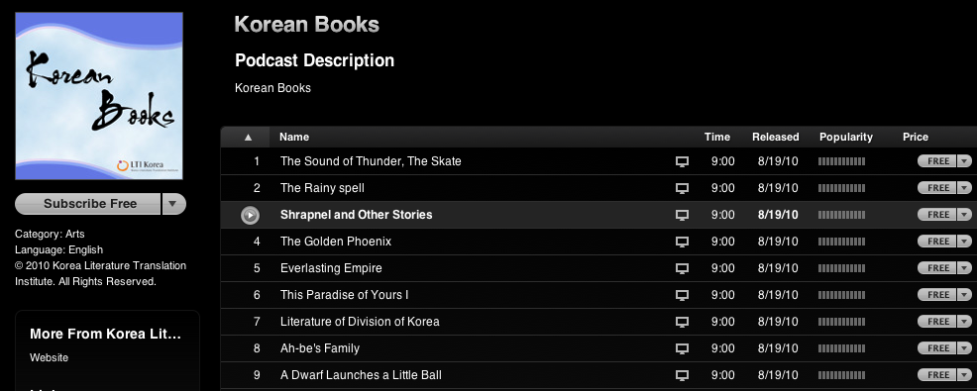
Finally, it is also clear that, as Marzena Stefanska-Adams noted earlier, something must be done to sort out Romanization once and for all. Park Wan-so/suh/seo/sŏ is a classic example of this problem. I find McCune-Reischauer to be incredibly difficult for English-language readers, but even more problematic is that to find all the works of an author, on often has to know the many different ways the author’s name can be Romanized.

III ASSESSMENT
Another major shift in the translation process should be a move towards a formal assessment process of the “success” of translation. Currently, goals are rarely used to assess outcomes and outcomes are rarely compared to goals except in the most general way. Translation should not be thought to end (or, more correctly, should continue in a cycle) when the impact of the translation in the TC has been formally compared against its goals (again, this requires the creation of explicit goals in translation). Goals, of course, do not have to be mercenary, and in this model if the goal is to “fill Asian Studies libraries with books only graduate students will read?” Then evidence those libraries have been filled will be evidence of triumph.
Formal pre-translation and post translation assessment is scarce. Mission statements need to be collected for inspection and explicitation of what goals they contain or what achievements they intend. For instance, the mission statement of the Korean Literature Translation Institute is:
LTI Korea’s mission is to fulfill the Korean government’s goal of contributing to global culture by spreading Korean literature and culture abroad.
This should be (and may well have been) parsed to explicate specific goals. These goals should suggest some of the elements of measurement that will constitute a rubric. By assessing success of translations based on constituent factors, we hope to allow translating institutions to have more focus when choosing works. In addition an inspection of outcomes might suggest whether a certain tactic seems appropriate to a goal, and whether outcomes suggest that the tactic was successful in the field. Too often, the mere translation and publication of a work is considered a ‘success.’
To attempt to measure the “success” of translated works, this paper analyzed two sources (Montgomery, Improving Translation and Publication Success for Korean Literature), Amazon.com and the Nielsen BookDataOnline database. First, Amazon rank was noted. Second, the number of reviews of particular works on Amazon was noted. This number is an imprecise but useful measure of reaction to particular works as well as certainly being related to availability of books. The current study refers to these as Amazon rankings.
Nielsen gathers a variety of information on international publishing and the most useful measure it offered seemed to be its list of the international markets in which particular books are sold. In addition to these measurements, Nielsen also notes the publisher of the individual works, as well as the country in which that publisher operates. In the future it would most likely also be instructive to note the size of publishing firms, their specialties the translators of the works, and a handful of other data.
The works surveyed were chosen as the results of Internet searches and included a complete list of translations done in the last 10 years, from Korean to English. This list was compiled by Brother Anthony of Taize (Brother Anthony or An Sonjae).
The first series considered was the Portable Library of Korean Fiction. The important results are shown in the following figure.
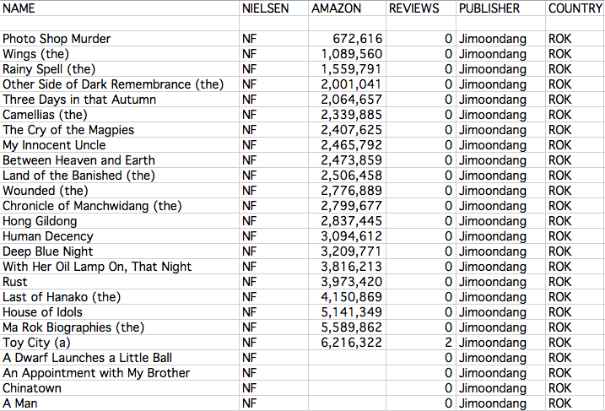
The “NF” notation for the Nielsen rating means that that not only are these books not being sold outside of Korea, but that the Nielsen rating system is completely unaware that these books have been published. These results are quite depressing, for they mean that these books, likely, have had little or no impact on readers outside of Korea – they have never been sold outside of Korea, or if they have it was for such a brief period of time, or with such little impact, that it might has well not have happened. In essence, these books have had no impact on English-language readers.
Finally, when judging content, it doesn’t seem a coincidence that the Jimoondang books that get into the top 2 million are:
- The Wings
- Photoshop Murder
- The Rainy Spell
- Three Days in That Autumn
- Other Side of Dark Remembrance

Three of these books are completely devoid of pundan munhak, and the other two begin as tales of entirely different sorts and are accessible to English-language readers from non-pundan perspectives. One provisional conclusion that can be drawn from these figures is that books with themes that are not ‘uniquely’ Korean are more likely to garner approval from English-readers.
Additional research, summarized in Figure Two, attempted to tease out the role of publisher and publication location in the success of translations.
Figure Two: International Publishing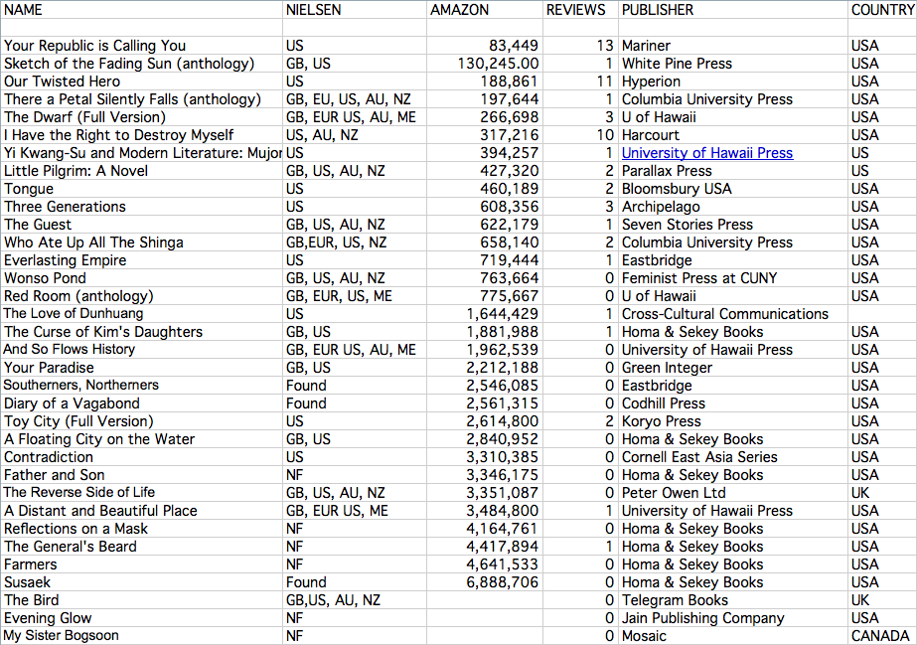

Certain conclusions seem to jump from these numbers. First and foremost, it seems obvious that foreign publication massively increases the chances of success of a Korean translation. Second, publication by a “mainstream” publisher seems strongly correlated to success of translations.
Mainstream publication is quite clearly important. Your Republic is Calling You is by far the most successful book on the list, and it is published by Mariner Books, which is part of Houghton Mifflin Harcourt a publishing firm of nearly 200 years experience and the largest K-12 publisher in the world. Harcourt (I Have the Right to Destroy Myself) is also part of Houghton Mifflin Harcourt. Hyperion Press (Our Twisted Hero) is a Disney-ABC affiliate. Columbia University Press (There a Petal Silently Falls) and the University of Hawaii Press (The Dwarf and Mujong) are among the most prolific and distinguished academic publishers in the United States. Bloomsbury USA (Three Generations) is a subsidiary of Bloomsbury Publishing, winner of the 1999 and 2000 Publisher of the Year Award. The only small presses represented amongst the top 10 are Archipelago (Three Generations) and White Pine Press. The bottom ten performers are, on the other hand, with one exception (University of Hawaii) small or specialty presses.
These differences can have many reasons – more savvy choices of translations, better marketing after publishing, better inroads into publishing, large firms can get reviews for their books, perhaps even they spend more money on designing attractive book covers (The Jimoondang and Homa & Sekey Books, for example, have covers that border on the perverse). But at some point, if translating agencies want success they are either going to have to figure out all the particular skills larger foreign publishers have, and apply them in other contexts, or just decide to use the tools that are most effective. Obviously, this is not as easy that, but surely continuing along the current road is inefficient?
It is also worth noting that the two books that were not published in the United States are among the three worst performers in the survey.
It is not fair, however, to just conclude that publishing in the United States in a panacea of any sort. Consider the fact that the seven books (and some of them qualitatively quite good literature) published in the United States by Homa & Sekey Books manage to limp in with a stunningly poor overall Amazon ranking of 4,026,001.
The other comparison that comes clear, as one compares the ‘internationally’ published books versus those published in Korea, is that the internationally published works seem to reach many more areas of the world, as revealed by the Nielsen data on international availability. This is scarcely surprising, but the point is that it should be taken into account.
CONCLUSION AND SUGGESTIONS
First, preliminary assessment suggests that commercial translation success of any kind pushes translation success of all kinds and thus the philistine notion of considering the western reader even before choosing a work to translate (and thinking of him/her throughout the entire translation process) may be the single most important point in globalizing Korean literature.
From that recognition, my recommendations flow; First, have clear goals in the target language; Second, assess what your audience wants, NOT want you think it needs; Third, use the translation process to create works that appeal to the intended audience, and finally; Assess outcomes to ensure that goals have been achieved (and if not, to determine what should be done in response).
Of course, also continue the work that has been done: Train translators and translate works (including, of course, works that are culturally important). Translator training is already paying off, as is the increasing internationality of Koreans and ethnic Koreans overseas. While there is a sometimes obsessive focus on translating the “right” works in the “right” way, translations have been getting better and the field of translated fiction has broadened substantially in the last decade. Translation quality is important, but it is far from paramount. In the last 10 years I have only seen two or three works with aggressively bad translation. More often, I have seen translations of works that I was not interested in, or could not understand.
Finally, some recommendations, which follow from these arguments, in bullet-points:
- Use market surveys to choose translated works
- Choose genred work to lead the market
- Try to find lighter, even humorous works
- Use translation teams who can re-create the knowledge base of the author
- Publish overseas
- Focus on women
- Enter international contests
- Market appropriately (from cover design to genre)
- Take advantage of the opportunities presented by social media/e-publishing
- Translate short stories with a focus on magazine publication
- “Fix” Romanization
Korean literature stands poised to follow the examples of Korean music and drama and leap to international status. With the strategic help of Korean institutions such as LTI Korea, this leap can be hastened and augmented.
REFERENCES
KTLIT, An MP3 Interview with translator Chi-Young Kim (“Please Look After Mom” among others). Part I. MP3 file accessed July, 23, 2011. http://www.ktlit.com/korean-literature/an-mp3-interview-with-translator-chi-young-kim-please-look-after-mom-among-others-part-i
Montgomery, Charles. Genre and Translation. Presented at Ehwa University. Version available online: http://www.ktlit.com/?p=3584
Montgomery, Charles. Improving Translation and Publication Success for Korean Literature. Presented November 14, 2010 at Dongguk University. Version available online: http://www.ktlit.com/?p=2392

Attempting to portray Cho Se-hui’s “The Dwarf” as a story of positive struggle is at best utterly tone-deaf to the writing, and at worst, absolutely incorrect.
NOTE: Amazon ratings were averaged over two samplings and a third sample has recently been added.

