Introduction

The “genre” filter serves as a brief and necessarily sketchy reminder of the vital importance of assessing the genre-membership of texts, and discovering their genre-related characteristics (Hervey et. al. p 217)

Because so much of the discussion about translation centers on process at various levels: Literal versus meaning; General issues of linguistic translation; and cultural issues, one of the less explored relationships between translation and success of that translation is that between genre and impact in the target culture. In a sense, we focus so tightly on the process of translation that we sometimes ignore the larger issues, such as what can be translated and what should be translated.
In that lens, this paper will discuss the role of genre on several levels. On the macro level it will explore the fits, and misfits, between Korean literary and English-language genres and how this impacts choices of translations and their successes. At the micro level, this paper will briefly discuss how genre affects translation in specific realms such as translator and idiom choice.
It should be noted from the outset that while this paper will focus on sales as its metric of success, it does not mean to unilaterally discard other goals of translation, such as communication of cultural content, or education. Rather, the now-stated assumption of this paper is that this communication and/or education is best served by getting English readers to begin to read virtually any Korean fiction and that in some ways virtually all goals of translation from Korean to English are met by instituting a more genre-based approach.
The Importance of Literary Genre
The macro level has to do with success and it derives from the observation, first anecdotally, that works from Korean into English that had a comfortable genre into which they could settle, were easier for the author to read. This led to speculation that other English-language readers might feel the same way. Hardly a scientific speculation, but one that led some interesting research.
Certainly, in reading Kim Young-ha’s Photo Shop Murder, the author of this paper was lulled into a relatively comfortable state by the first line, “Why do murders always seem to happen on Sundays” (Kim Young-ha, p. 7)? To a westerner this was the familiar voice of the hard-edged detective – Sam Spade, Philip Marlowe, or even the more modern James Rockford. Pursuant to this, a semi-scientific look into Amazon rankings, the New York Times Bestseller List, and the Neilsen Book Ratings seemed to reveal that books in easily identifiable western genres performed better in terms of sales.
This first recognition that genre choice might be important to the success of translations led to a line of informal research that initially focused on the excellent Jimoondang/KLTI series of 25 small novels, novellas, and short stories. Looking at the Amazon success rates of at these stories one thing was clear: Among the only five volumes to rank in the top two million on Amazon, a convenient “western” genre could be assigned to each. A majority of the remaining works were difficult to assign to a Western genre. In an informal online canvass, three literary westerners currently in Korea could not assign genres to most of the Jimoondang books that sank in the Amazon ratings. But as one inspect the list of Jimoondang works, one clearly sees ‘understandable’ works rising and difficult works receding.
On the other hand, when one starts to look at the recent successes in translated Korean literature, there is a uniform ability to assign a genre to those works that have been successful. The last two examples of this, of course, have been Kim Young-ha’s Your Republic is Calling You and Shin Kyung-sook’s breakthrough Please Look After Mom, the latter of which has been a massive success, recently reaching number fourteen on the New York Times Best Seller List. Genre is, of course, not the only similarities that these books share: The successful translations are also marked by other substantial similarities: They are published outside of Korea; they are translated by a small group of translators who frequently seem to achieve success and, perhaps most critical; they are published by major publishing firms and have strong marketing support in the English-speaking world (Montgomery). These similarities, however, are clustered around the works that can be genred, precisely because these are the works a good translator and foreign publisher would choose. A quick look the New York Times Bestseller List reveals that un-genred works are generally absent even when written by native English-writers. Genre seems to have a powerful effect on the success of any or all published books.
Genre success leads to General Success
But the effect is far more wide-reaching than the success of specific authors suggests. In fact, studies of the Amazon rankings of the PLKF indicate that the success of genred fiction creates a parallel success in more traditional translated fiction across the board. As the success of Kim Young-ha’s “Your Republic is Calling You” waned, so did the average ranking of PLKF books, falling over 12%. On the other side of the coin, the massive publication success of Shin Kyung-sook’s book provided the PLKF books with an aggregate ‘bounce’ of over 20%. The evidence seems to suggest that the success of international bestsellers actually drives the success of the larger body of Korean modern fiction.
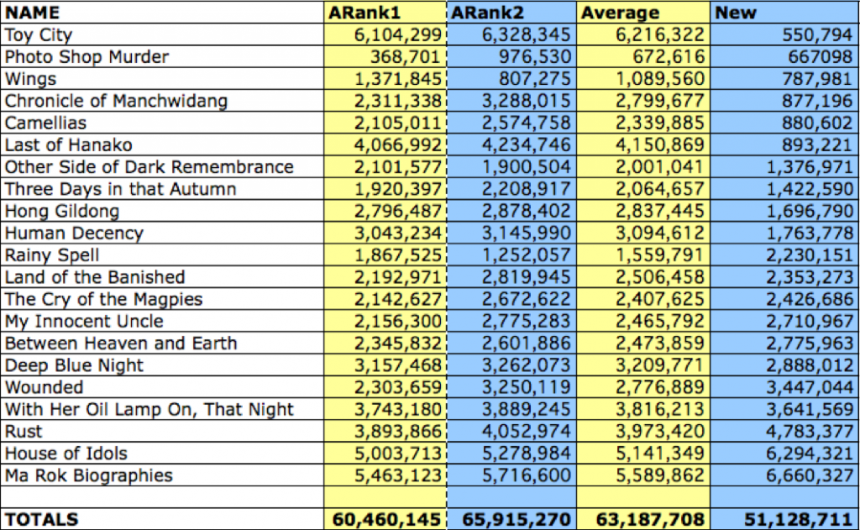

This demonstrates that as the popularity of Your Republic is Calling You waned, so did the overall success of the LTI Korea/Jimoondang books. But when Please Look After Mom took off, the LTI Korea/Jimoondang books shot up between 15% and 22.5% depending on how you defined the baseline.
This is at least partly due to the ‘suggestive’ nature of the internet, as Amazon and Barnes and Noble have a recommendation feature that suggests related literature to browsers who are interested in Korean literature bestsellers. Any potential reader searching for Please Take Care of Mother will also at least lay their eyes on three other works of Korean fiction on these pages, and this is a powerful branching tool.

In fact, this will likely work across Korean translated literature in general, as Amazon and Barnes and Noble have a recommendation feature that suggests similar literature to browsers. Successes in Korean translated literature will, in this way, lead to other, related successes.
Genres: Short vs. Long
There are other genre issues as well, and ones that don’t seem to always occur to translators or translation institutes. Consider the highest level of genre for literature: Novel; short story, or; poetry. It is received wisdom in the west that short story collections simply do not sell as well as novels. In 2007 Newsweek noted:
There’s no doubt that short fiction has disappeared from the zeitgeist. Today, stories are communicated to wide audiences only if they’re made into movies. Any publisher will attest that short story collections don’t sell well. (Livings)

And yet Korea, as a translating entity, has spent millions of won on translating collections of short stories (most of which suffer from the lack of western genre which is the general topic of this paper). Deeply involved readers of translated Korean modern literature are happy that these works exist, but would scarcely recommend them to friends, both based on content and form. It is also worth noting that these collections of short stories tend to contain massive amounts of content repetition.
An example that I frequently use is the Korean classic, Buckwheat Season. This work is in at least ten anthologies, in fact, it has an anthology dedicated to it alone; Buckwheat Season reproduced in five languages in one slender volume. Even if a reader is tempted to purchase short story collections, they might sensibly be wary of unknown collections of Korean fiction (this problem is amplified by the fact that author names are frequently Romanized differently and the same stories sometimes get different titles). And Buckwheat Season is also a classic example of a story that has no genre in the west. It might be called “romantic/bucolic” in Korean, but since Thoreau died in the United States, that genre has faded into obscurity. A great work in Korean, a great work for serious students of Korean culture or literature, a work that should never be translated again.
In fact, likely the only genres for which short stories should be translated are the “best stories of..” and academic anthologies. Why? Because these short story genres have built in audiences. The “best of” compilations appeal to a small demographic, but a loyal one. Academic anthologies, on the other hand, are generally pressed on students, but eyes can be opened this way, nonetheless, and they do represent a guaranteed, if small, market share. Even given these audiences, the stories submitted should be genred (or exceptional) in a way that lends itself to Western audiences.
What happens when good genred work is translated? Figure 1 shows traffic for the last year for www.ktlit.com, a website dedicated to Korean literature in translation. By going back and checking the spikes on the graph against the daily posts, it is immediately clear that all the spikes were driven by news, in the Western world, of authors who hit genres, In this case Kim Young-ha and Shin Kyung-Sook. When a genred work is released, it also releases general interest.
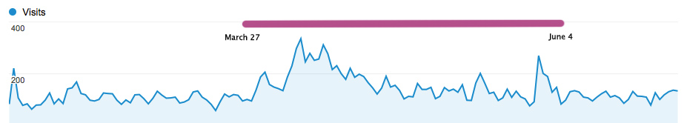
Figure 1: KTLIT Traffic for Shin Kyung-sook
Genres, it turns out, are important.
Thus it comes as no surprise that Please Look After Mom is such an epic success, already, in the United States. It fits nicely into the Amy Tan / Oprah niche of stories of sainted/interesting mothers. As Joseph Lee, president of KL Management, the firm dealing with the copyright for the novel notes:
“Mom is universal material for a novel because everyone has a mom. And every one loses mom some how. That feeling of loss resonates with people not only in the U.S. but in other countries,” Lee told The Korea Herald. (Kim Yoon-mi)

Which is true as far as it goes, but remember, this version is genred in a way English speakers will get. On the other hand, the “loss” of the mother in Yi Pom-son’s Stray Bullet to madness, the pre-existing loss of the mother in Hwan Sun-won’s Stars or the hideously ironic loss of a mother portrayed by Kim Yong-ik in his Mother’s Birthday? These land in no comfortable arena for English speaking readers, and thus are difficult to read, more difficult to digest, and in Stray Bullet, at least, for incomprehensible reasons to most English speaking readers.
Sometimes there aren’t parallel genres and this makes translation difficult. This paper mentioned, above, Buckwheat Season. Even when parallel genres can be identified, this is no guarantee of success. In conversations on KTLIT there have been multiple discussions of genre. There, it was noted that the top two genres, measured by sales success, are romance and mystery, with romance accounting for over 50% of all sales in 2008 with mysteries and science fiction coming in second and third. (Grischy)
When one looks at the implications of this for translation of fiction from Korean to English, the results are sobering.
Romance, though similar in overall genre, has such substantial cultural differences that it is unlikely that a success will move from Korean to English. English-language romances generally feature heavy sexuality and often a romantic historical background: In English these works are referred to as “bodice rippers.” In translated Korean fiction, sexuality is typically non-existent or relatively chaste, and if any bodice is getting ripped (particularly in the pundan and ‘miracle on the Han’ munhaks), it is likely in the process of a rape. As a non-Korean speaker, I can’t judge if there are any works behind the veil of language that might be more suitable for translation to English, but I can say that what has been translated hasn’t fit well, even if it has putatively included ‘romance.’
Related to and overlapping with romance is chick-lit. Bridget Jones’ Diary and Sex and the City were massive hits, both as books and video in Korea and did result in a wave of Korean chick-lit. Heejung Jung, a PhD student at Dongguk University has done some work in this area, primarily focusing on hegemonic imbalances in publishing. She notes that the introduction of the Western chick-lit did directly lead to domestic production of chick-lit, including 티겟마라노 (Ticket to Milan), 달콤한 나의 도시 (My Sweet Seoul), 걸프렌드 (Girlfriend) and 스타일 (Style). But, Ms. Jung noted, produced in Korea, these works lack heavy romantic content and never venture as far into the sexual arena (see above) to translate well for Western readers who expect a large dose of sexuality in such works.
Mysteries, some times including police procedural and other sub-genres are another ready-made genre. In general there don’t seem to be many of these translated, but the ones that have been translated, notably Kim Young-ha’s procedural Photo Shop Murder and the brilliant mystery/horror story in the recent Waxen Wings called Corpses by Pyeon Hye-yeong, read quite easily and understandable for English readers. This might represent a genre in which Korean literature can be successful.
Science Fiction seems to be fairly rare (Sellar) in Korean fiction (though perhaps some North Korean fiction qualifies?^^). The fact that Korean fiction is so based in reality, and that the ideas of agency and heroism in the Western sense are often absent means that science fiction is unlikely. When science fiction is written, seems derivative or to be covering territory previously covered in the West. This last point may because the genre is still in development.
The point of all of this is that genres works are generally successful works, written in English or translated.
Moving to the Micro Level
The fact that genres are related to success and consequently should be considered in translation also has impacts on the translation process, from choice of translator to choice of translation process, choice of book covers, even to consideration of the impacts that genres might have on idiom and trope usage.
The Role of Translator
First let us consider the importance of translator. Please Look After Mom has been a massive success, and this is largely because it fits perfectly into a genre, as has been mentioned here before. But there is more to it than just that – it required a genre-aware translator. Chi-young Kim notes. “Korean novels can meander and repeat words or phrases or parts of scenes, but that doesn’t translate well into English. It tends to read like a mistake (Chung).” More important, Kim notes that one of the reasons that Please Look After Mom was successful was that Shin Kyung-Sook was willing to re-write her novel to make it cohere better to genre expectation in English. Korean novels often also don’t always end up at a point. These realities break conventions in modern English literature. Chi-young Kim (successful on four successive translations) is aware of this and makes adjustment. In fact, in an interview with ktlit.com she notes that she has been lucky to work only with living authors, which makes emendation much easier.
Chi-young Kim also notes that when she translated Kim Young-ha’s Your Republic is Calling You, she was frequently forced to resort to Kim Young-ha to understand aspects of Kim’s post-modern genre:
Kim Young-ha’s books, for example, contained scenes around card games/hwatu, cars, sports, and video games. Stereotypically, I know next to nothing about those topics, so a major concern was conveying those scenes authentically. So, for example, I didn’t know anything about StarCraft, and in Your Republic Is Calling You, there is a whole section detailing the action on someone’s computer screen. I looked up the terminology of different characters and weapons, did a draft of that section, then found someone who plays StarCraft to read it over and give me pointers. That person edited that section with the language StarCraft aficionados (sic) use. (Chung)

In essence, Chi-young Kim used “multiple” target culture editors, but she didn’t do this in order to check the grammar or structure of her work, instead she was concerned that the language be appropriate for the work’s genre and/or niche.
Micro-Micro: Specific Translation Decisions
Finally, and a small point, but one that needs to be clear, the choice of genres to translate also has impact on the technical translation process. Some idioms, tropes, grammatical structure, etc. are tightly tied to their genres. Consider even the simplest idiom in Korean, “licking the outside of the watermelon.” If this is were used in the Korean pastoral/romantic genre (particularly) this needs to be taken into account in translation. It might be tempting to translate this as “beating round the bush” in English, except that is a very non agrarian idiom, as it is redolent of rifles, feudal class structure, and pheasants on the rise. “Scratching the surface,” may not be as idiomatic, but it probably serves a genred translation better. Translating a genred work, as suggested above by Chi Young-kim, requires a translator with command of the idioms of the genre.
“Covering” Everything in Translation
As previously mentioned, both Your Republic is Calling You and Please Look After Mom are both immediately categorizable to English-speaking readers who open the books and read them. Kim Young-ha’s book is a mystery/thriller, and Shin Kyung-sook’s is an Oprah-type tearjerker. In the interests of accessibility to western audiences, even the titles were changed, and not only from their literal meanings in Korean: In the case of Shin Kyung- sook’s Please Look After Mom, there were two different titles in English (to accommodate US/UK differences in idiom).
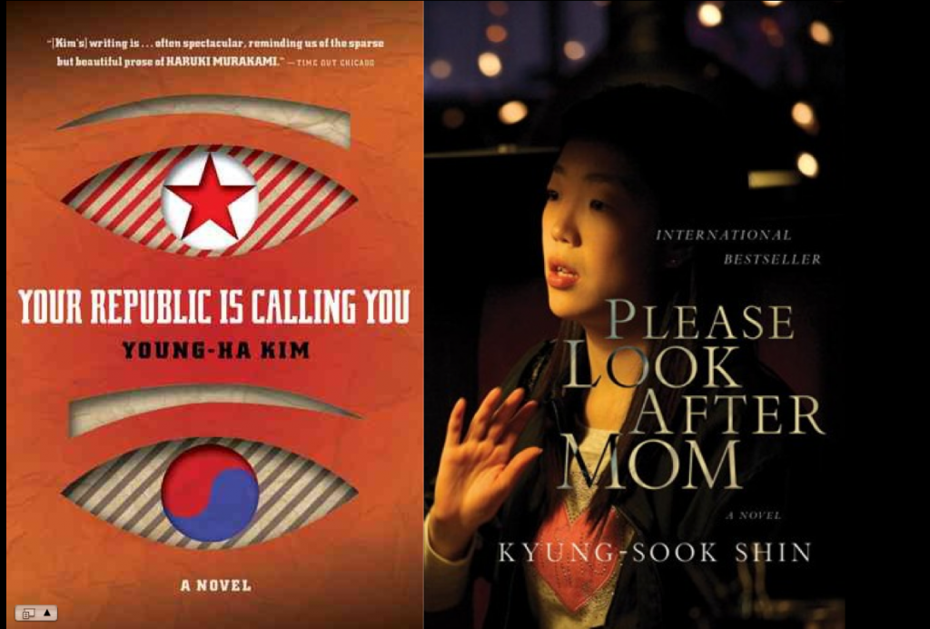

Looking one step closer, we can see that even the covers were designed to emphasize the genred nature of the books, and this certainly helped potential readers decide to choose them. The success of these two books should not come as a surprise. Compare these covers to the book covers of the otherwise excellent PLKF publications. These covers feature dull monotones and reversed-hangul designs that are difficult to decipher even if one reads Korean, much less if one is an English-language reader.

Conclusions
In many ways, it might be that this paper is being obsoleted at the time of its own delivery. The last year in translation of Korean modern literature has been a watershed year. Success has followed success.
Still, it seems not a waste of time to look at issues like the role of genre, or for that matter why overseas marketing of Korean literature is not the default approach, here in Korea. This is where many of us live. We are the people most deeply interested and involved in translated Korean literature, and while overseas successes are grand, it is the mission of everyone here to increase those successes.
With that in mind, it is good to have discussions that help us maximize success. The message today is simple. Consider genre when choosing works to translate, who should translate them, based on understanding of genre, and how they should be translated based on that same understanding.
The message not given in this paper is also simple. Marketing is NOT the end all and be all, and the desire of Koreans to express their culture, both in differences and similarities, is no different from the desire of any other nation. Don’t stop translating non-genre, difficult, or historically specific work. Korean modern literature has been intensely a national literature and that reflects the concerns of the nation. But be wise on how to get that literature out there. And part of that wisdom begins in understanding what is likely to work and what is likely to fail.
With that in mind, this paper will present one last piece of information that seems to demonstrate that marketing can solve multiple problems. Earlier, this paper presented some numbers demonstrating that the KLTI/Jimoondang had not had the impact they might have. It’s time to revisit those numbers. When those numbers were revisited AFTER the successes of the last three books? Overall their popularity had increased over 22% from the previous average scores. This means that not only did all those new books sell – but the old, classic stories sold better as well. Substantially better. This seems to be the classic win/win situation.
Very few westerners began eating hanshik with 홍어 and while Koreans in general, the government, and newspapers note with approbation the impact of 한류 they seldom seem concerned that it is largely composed of relatively lightweight pop-culture. Pansori, so to speak, is not selling in Thailand.
The same should be true of the introduction of Korean literature to the west. Begin with what works, and make those things work for Korea. It was only 40 years ago that Japanese literature landed in the west; now Tom Cruise can be a Samurai. Continue the successes of recent translations by following the genre trail for a period, and Korean literature, along with its food and products, will assume a fitting place in the international world of literature.
So to your palette of tools, says someone who generally sits on the sideline until it is time to edit, to those of you here who do the real work, consider adding the genre filter.

REFERENCES

Chung, J, Won. Interview: Translator Chi-Young Kim (Part I of 2). Subject object verb. http://subjectobjectverb.com/2011/04/08/interview-with-translator-chi-young-kim-part-i-of-ii/

Grischy, Janet. The best selling genres in paperback fiction. Helium: Writing for Success. December, 16, 2008. http://www.helium.com/items/1268494-the-best-selling-genres-in-paperback-fiction

Hervey, Sándor G. J., Ian Higgins, Louise M. Haywood. Thinking Spanish translation: a course in translation method, Spanish to English. Routledge Publishing. 1 edition, December 7 1995.

Jung, Heejung, Asymmetry in Translated Literature: The Case of “Chick Lit” and Korea. Presented at Writing Past Each Other. Victoria University of Wellington, 11-13 December 2010.

Kim, Yoon-mi. Korean novel gets world’s attention. in Korea Herald. 2011-04-08 19:19 http://www.koreaherald.com/pop/NewsFlashRight.jsp?newsMLId=20110408000618

Kim Young-ha, Photo Shop Murder. Jimoondang Publishing Company. Seoul, Korea. 2003.

Livings, Jack. Note to King: Don’t Sell Short Stories Short. Newsweek. November 02, 2007. http://www.newsweek.com/2007/11/01/note-to-king-don-t-sell-short-stories-short.html

Montgomery, Charles. Goals, Outcomes, Assessments: Completing the loop from a marketing perspective. Presented at Writing Past Each Other. Victoria University of Wellington, 11-13 December 2010.

Sellar, Gord. My Thought on SF in Korea (How and Why They’ve Changed). At www.gordsellar.com. www.gordsellar.com/2008/08/17my-thoughts-and-how theyve-changed/

